**Assignment No. 14**

**Create an elastic IP for an instance.**

**Visit** **aws.amazon.com** **and Sign in.Go to EC2 dashboard and click “Instance” and then click on “Launch instances”**

**Enter instance name and select Ubuntu as AMI**

**1.….**.

**2.**

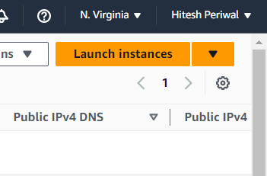

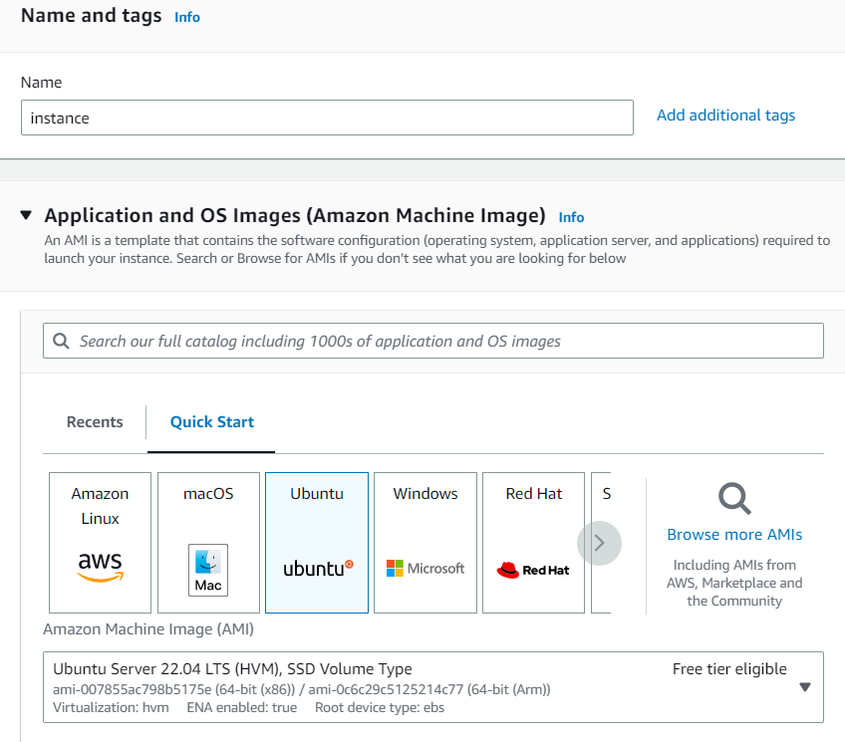

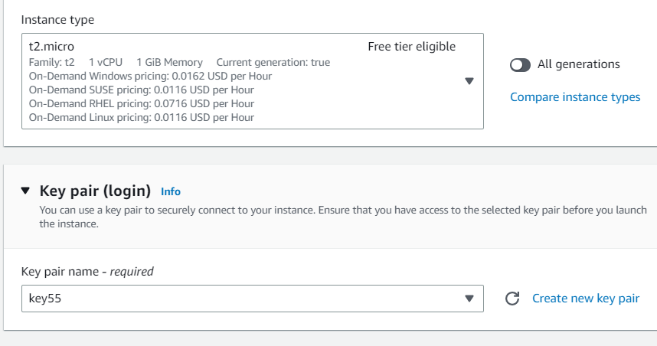

**s**

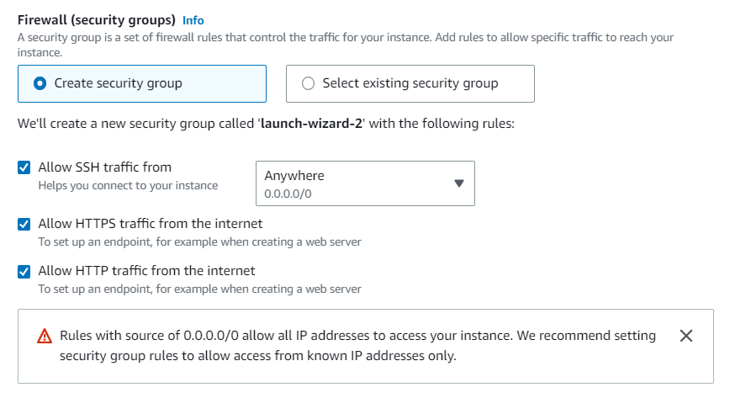

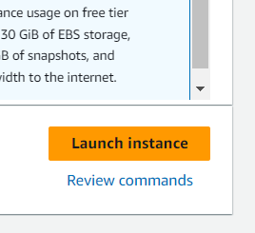

**Select t2.micro as instance type and a keypair**

**Under firewall select create security group and select all the three traffic options**

**3.**

**4.….**.

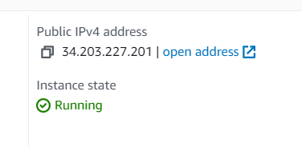

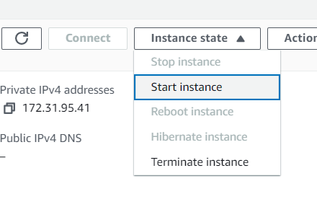

**Now go to the instance created .Change its state to stop.After its successfully stopped ,again start it.It will be observed that its public IPv4 will change.**

**Go to EC2 dashboard and select “Elastic IPs”.Then click on “Allocate Elastic IP address” and “Allocate”. Select the elastic ip address,go to “Actions” dropdown and select “Associate Elastic IP addresses”.**

**5.….**.

**6.**

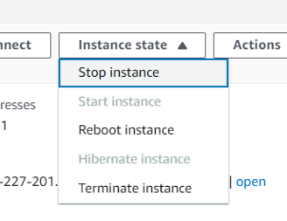

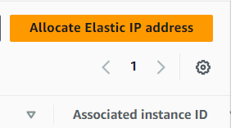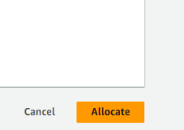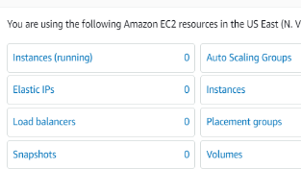

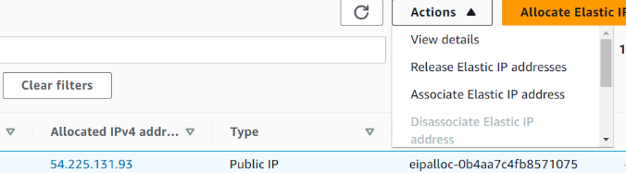

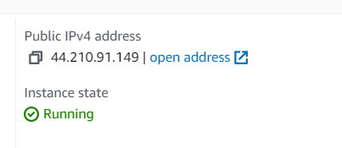

**Now go to the instance.Change its state to stop.After its successfully stopped ,again start it.It will be observed that its public IPv4 will remain same.Hence Elastic IP address is successfully associated with this instance.**



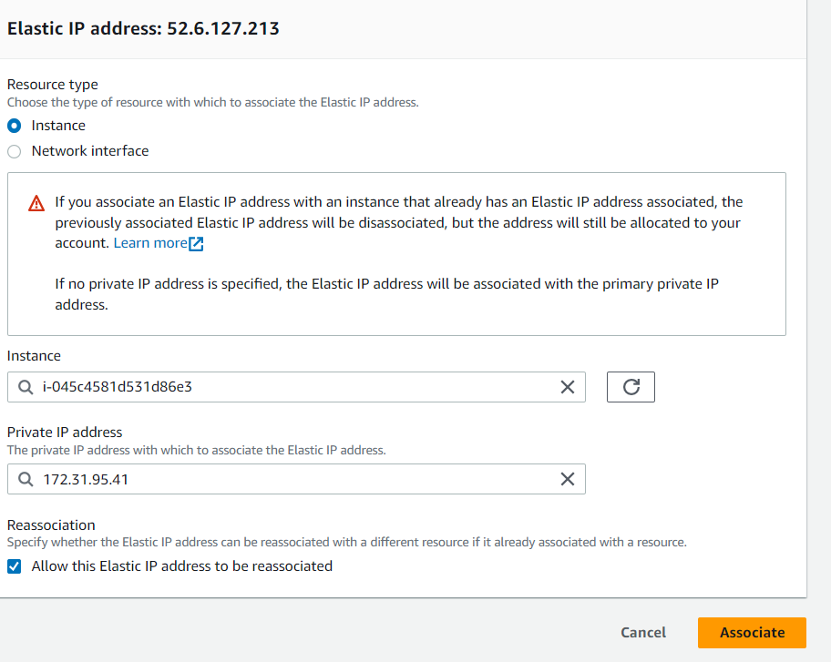

**Now select the instance and its private IP address.Click on checkbox which reads “Allow this Elastic IP address to be reassociated”.Then click on “Associate”**

**7.….**.

**8.**

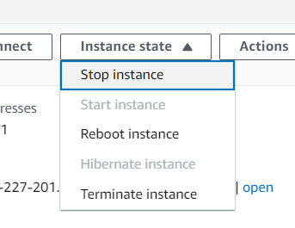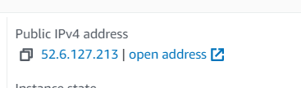



**To remove this Elastic IP address we need to first disassociate it and then release it.**

**9.**

